Nama : Adi Saepul Anwar
NPM : 43A87006200129
Kelas : S1/TI/AM/4
Matkul : Jarkom 2

Topologi

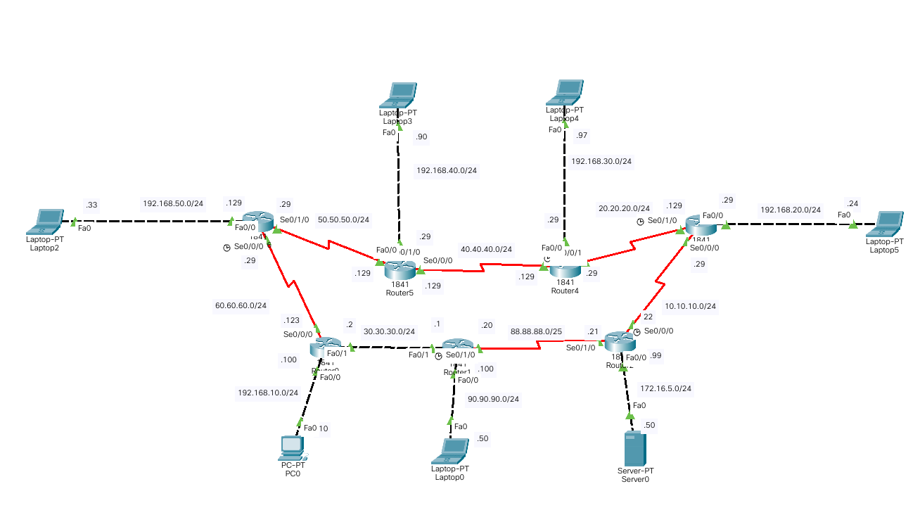

#Konfigurasi
Router 3
interface FastEthernet0/0
ip address 192.168.20.29 255.255.255.0
duplex auto
speed auto
!
interface FastEthernet0/1
no ip address
duplex auto
speed auto
shutdown
!
interface Serial0/0/0
ip address 10.10.10.29 255.255.255.0
!
interface Serial0/0/1
no ip address
clock rate 2000000
shutdown
!
interface Serial0/1/0
ip address 20.20.20.129 255.255.255.0
clock rate 2000000
!
interface Serial0/1/1
no ip address
clock rate 2000000
shutdown
!
interface Vlan1
no ip address
shutdown
!
router rip
version 2
network 10.0.0.0
network 20.0.0.0
network 192.168.20.0

Router 4
interface FastEthernet0/0
ip address 192.168.30.29 255.255.255.0
duplex auto
speed auto
!
interface FastEthernet0/1
no ip address
duplex auto
speed auto
shutdown
!
interface Serial0/0/0
ip address 40.40.40.129 255.255.255.0
clock rate 2000000
!
interface Serial0/0/1
ip address 20.20.20.29 255.255.255.0
!
interface Serial0/1/0
no ip address
clock rate 2000000
shutdown
!
interface Serial0/1/1
no ip address
clock rate 2000000
shutdown
!
interface Vlan1
no ip address
shutdown
!
router rip
version 2
network 20.0.0.0
network 40.0.0.0
network 192.168.30.0

Router 5
interface FastEthernet0/0
ip address 192.168.40.29 255.255.255.0
duplex auto
speed auto
!
interface FastEthernet0/1
no ip address
duplex auto
speed auto
shutdown
!
interface Serial0/0/0
ip address 40.40.40.129 255.255.255.0
!
interface Serial0/0/1
no ip address
clock rate 2000000
shutdown
!
interface Serial0/1/0
ip address 50.50.50.129 255.255.255.0
clock rate 2000000
!
interface Serial0/1/1
no ip address
clock rate 2000000
shutdown
!
interface Vlan1
no ip address
shutdown
!
router rip
version 2
network 40.0.0.0
network 50.0.0.0
network 192.168.40.0

Router 6
interface FastEthernet0/0
ip address 192.168.50.129 255.255.255.0
duplex auto
speed auto
!
interface FastEthernet0/1
no ip address
duplex auto
speed auto
shutdown
!
interface Serial0/0/0
ip address 60.60.60.29 255.255.255.0
clock rate 2000000
!
interface Serial0/0/1
no ip address
clock rate 2000000
shutdown
!
interface Serial0/1/0
ip address 50.50.50.29 255.255.255.0
!
interface Serial0/1/1
no ip address
clock rate 2000000
shutdown
!
interface Vlan1
no ip address
shutdown
!
router rip
version 2
network 50.0.0.0
network 60.0.0.0
network 192.168.50.0

Table Route

Router 3 | Router 4 | Router 5 | Router 6
Gateway of last resort is not set  10.0.0.0/24 is subnetted, 1 subnets  C 10.10.10.0 is directly connected, Serial0/0/0  20.0.0.0/24 is subnetted, 1 subnets  C 20.20.20.0 is directly connected, Serial0/1/0  R 30.0.0.0/8 [120/2] via 10.10.10.22, 00:00:27, Serial0/0/0  R 40.0.0.0/8 [120/1] via 20.20.20.29, 00:00:25, Serial0/1/0  R 50.0.0.0/8 [120/4] via 10.10.10.22, 00:00:27, Serial0/0/0  R 60.0.0.0/8 [120/3] via 10.10.10.22, 00:00:27, Serial0/0/0  R 88.0.0.0/8 [120/1] via 10.10.10.22, 00:00:27, Serial0/0/0  R 90.0.0.0/8 [120/2] via 10.10.10.22, 00:00:27, Serial0/0/0  R 172.16.0.0/16 [120/1] via 10.10.10.22, 00:00:27, Serial0/0/0  R 192.168.10.0/24 [120/3] via 10.10.10.22, 00:00:27, Serial0/0/0  C 192.168.20.0/24 is directly connected, FastEthernet0/0  R 192.168.30.0/24 [120/1] via 20.20.20.29, 00:00:25, Serial0/1/0  R 192.168.40.0/24 [120/5] via 10.10.10.22, 00:00:27, Serial0/0/0  R 192.168.50.0/24 [120/4] via 10.10.10.22, 00:00:27, Serial0/0/0 | Gateway of last resort is not set  10.0.0.0/24 is subnetted, 1 subnets  C 10.10.10.0 is directly connected, Serial0/0/0  20.0.0.0/24 is subnetted, 1 subnets  C 20.20.20.0 is directly connected, Serial0/1/0  R 30.0.0.0/8 [120/2] via 10.10.10.22, 00:00:27, Serial0/0/0  R 40.0.0.0/8 [120/1] via 20.20.20.29, 00:00:25, Serial0/1/0  R 50.0.0.0/8 [120/4] via 10.10.10.22, 00:00:27, Serial0/0/0  R 60.0.0.0/8 [120/3] via 10.10.10.22, 00:00:27, Serial0/0/0  R 88.0.0.0/8 [120/1] via 10.10.10.22, 00:00:27, Serial0/0/0  R 90.0.0.0/8 [120/2] via 10.10.10.22, 00:00:27, Serial0/0/0  R 172.16.0.0/16 [120/1] via 10.10.10.22, 00:00:27, Serial0/0/0  R 192.168.10.0/24 [120/3] via 10.10.10.22, 00:00:27, Serial0/0/0  C 192.168.20.0/24 is directly connected, FastEthernet0/0  R 192.168.30.0/24 [120/1] via 20.20.20.29, 00:00:25, Serial0/1/0  R 192.168.40.0/24 [120/5] via 10.10.10.22, 00:00:27, Serial0/0/0  R 192.168.50.0/24 [120/4] via 10.10.10.22, 00:00:27, Serial0/0/ | Gateway of last resort is not set  R 10.0.0.0/8 [120/4] via 50.50.50.29, 00:00:25, Serial0/1/0  R 20.0.0.0/8 [120/5] via 50.50.50.29, 00:00:25, Serial0/1/0  R 30.0.0.0/8 [120/2] via 50.50.50.29, 00:00:25, Serial0/1/0  40.0.0.0/24 is subnetted, 1 subnets  C 40.40.40.0 is directly connected, Serial0/0/0  50.0.0.0/24 is subnetted, 1 subnets  C 50.50.50.0 is directly connected, Serial0/1/0  R 60.0.0.0/8 [120/1] via 50.50.50.29, 00:00:25, Serial0/1/0  R 88.0.0.0/8 [120/3] via 50.50.50.29, 00:00:25, Serial0/1/0  R 90.0.0.0/8 [120/3] via 50.50.50.29, 00:00:25, Serial0/1/0  R 172.16.0.0/16 [120/4] via 50.50.50.29, 00:00:25, Serial0/1/0  R 192.168.10.0/24 [120/2] via 50.50.50.29, 00:00:25, Serial0/1/0  R 192.168.20.0/24 [120/5] via 50.50.50.29, 00:00:25, Serial0/1/0  R 192.168.30.0/24 [120/6] via 50.50.50.29, 00:00:25, Serial0/1/0  C 192.168.40.0/24 is directly connected, FastEthernet0/0  R 192.168.50.0/24 [120/1] via 50.50.50.29, 00:00:25, Serial0/1/0 | Gateway of last resort is not set  R 10.0.0.0/8 [120/3] via 60.60.60.123, 00:00:01, Serial0/0/0  R 20.0.0.0/8 [120/4] via 60.60.60.123, 00:00:01, Serial0/0/0  R 30.0.0.0/8 [120/1] via 60.60.60.123, 00:00:01, Serial0/0/0  R 40.0.0.0/8 [120/1] via 50.50.50.129, 00:00:02, Serial0/1/0  50.0.0.0/24 is subnetted, 1 subnets  C 50.50.50.0 is directly connected, Serial0/1/0  60.0.0.0/24 is subnetted, 1 subnets  C 60.60.60.0 is directly connected, Serial0/0/0  R 88.0.0.0/8 [120/2] via 60.60.60.123, 00:00:01, Serial0/0/0  R 90.0.0.0/8 [120/2] via 60.60.60.123, 00:00:01, Serial0/0/0  R 172.16.0.0/16 [120/3] via 60.60.60.123, 00:00:01, Serial0/0/0  R 192.168.10.0/24 [120/1] via 60.60.60.123, 00:00:01, Serial0/0/0  R 192.168.20.0/24 [120/4] via 60.60.60.123, 00:00:01, Serial0/0/0  R 192.168.30.0/24 [120/5] via 60.60.60.123, 00:00:01, Serial0/0/0  R 192.168.40.0/24 [120/1] via 50.50.50.129, 00:00:02, Serial0/1/0  C 192.168.50.0/24 is directly connected, FastEthernet0/0

